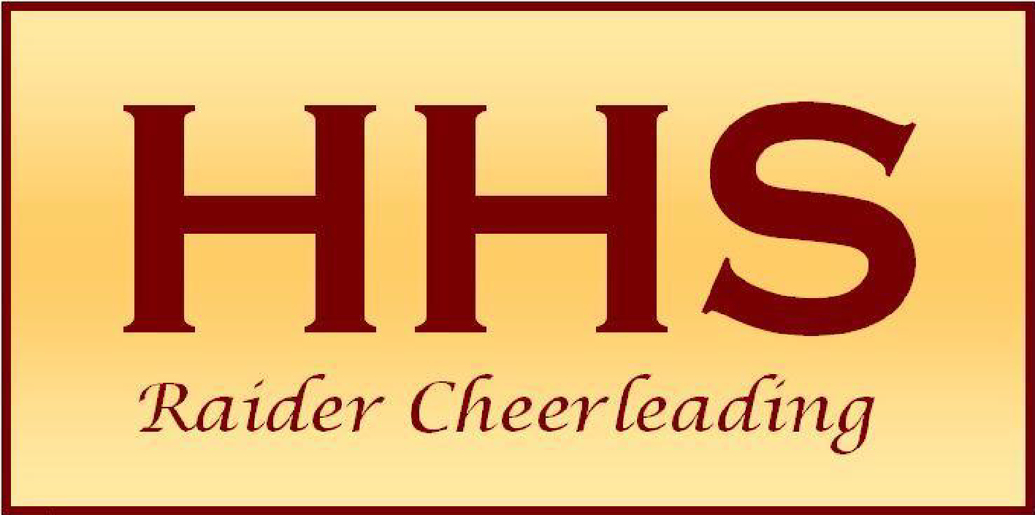
HHS Booster Club Meeting Minutes
November 19, 2025

Attendees:

Stacey Dagostino
Mary Lynn Steele
Mandi Steinhauser
Alia Gordon
Joanna Robison
Kimberly Ercolino
Michelle Cuevas
Mindi Steinhauser
Christine Meyer
Barbra Churco
Christina Gonzalez
Rosa Pinho
Lee.g
Meredith Church
Jamie Mejia
Maria Federico

Dine Outs - Dates to be solidified

End of Season Banquet
December 3rd 6pm, $20 per parent/guest and cheerleaders are covered by the Booster Club
- Instructions are in Band, please venmo payment with cheerleader name

End of Season Slide show - email photos to raider1158@gmail.com
- Senior parents/cheerleaders to email 5-7 photos through the years by Monday 11/24
- If anyone else has additional photos that are desired, please also email those

Winter Varsity Basketball Cheer Tryouts
- Tryout dates: December 1,2,3
- Girls were shared info today regarding impact test, all girls interested need to try out
- All girls need to sign up through Genesis
- Girls will do a simple cheer, dance and stunting
- Winter cheer will practice Mondays and Tuesdays; most games will be on Tuesdays and Saturdays - girls cheer for home games
  - January - double headers 1st 3 Tuesdays; girls 5:15, boys 7pm
  - December - 13th, Th, Tuesday
  - If basketball team progresses to finals/playoffs, permission by school girls will travel with the team
- Girls sit on sidelines/bleachers and cheer, lots of individual stunting in small groups, ¼ and ½ time performance
- Winter Booster Club Membership dues are $30

Team Tumbling
- Coach to check to see if we can reschedule the 12/3 date due to banquet
- Check directly with Evolution re: makeup dates/times (non-individual)

Competition Cheer
Calendar Updates:
- Choreo clean-up Dec 4, 4-7pm
- Practices are dependent upon trainers being onsite
  - Next week practice on Tuesday 2:45-5:45pm only
  - After, comp practices will be Wednesdays until 12/17, end at 5pm and Thursdays end at 6pm
Upcoming Competitions
- Manalapan Jan 17 in question
  - Other considerations - Mt Olive
- Jersey Strong Showcase Jan 25, Watchung
- UCA Nationals - Feb 6-8
- NJCDCA State Championship @ Brookdale Feb 22
- Feb 2nd Dance and Cheer Showcase - Monday

Nationals:
- Athletes depart Feb 5 and return on Monday Feb 9
  - 12:30pm Flight out United 361 out of EWR, arrival time at HHS TBD
  - 6am flight home United 1105
  - Once all info is available, itinerary will be shared
  - *Total of flights $403 per athlete
- In January they will specify which hotel, will be a value hotel. Celebration event 9pm-1am
- Will have team dinner, bus transportation included. General meals are not included but meal vouchers are available on the UCA website.
- Spectator packages are available on the Varsity/UCA website

Krispy Kreme Doughnuts
Money due and can be turned into Barbra Churco at banquet
Need to sell at least 50 dozen or fundraiser will not occur

Basketball Concessions
Personal fundraiser for cheerleaders; parents or cheerleaders

Sponsorships
- Business or individuals - must indicate if for a particular cheerleader or if no name is indicated it is for the entire team
- Forms will go out right after Thanksgiving
- Company matching is eligible

