

2025-2026 HHS Raiders Cheer Booster Club
FALL MEMBERSHIP

Mission Statement
The HHS Raiders Cheer Booster Club is a non-profit 501c(3) organization whose goal is to lend support to the HHS cheerleaders and to the HHS cheerleading coaching staff. We strive to encourage and maintain enthusiastic interest through parents’ and community members’ participation in the various activities of the cheerleaders.

The HHS Raiders Cheer Booster Club encourages all parents/families to get involved by volunteering your time for events such as fundraising, Homecoming, the cheerleading banquets, Senior Night, and/or by making a donation to support the cheerleaders. The Booster Club membership allows us to provide scholarships to our seniors and extra “fun” activities and events for the cheerleaders that would otherwise not be possible without your participation.

___________ 2025 Annual Fall Dues: $30 one cheerleader / $50 two cheerleaders “Sibling Discount”

___________ I would like to make an additional donation to HHS Raiders Cheer Booster Club, LLC

Total amount enclosed _____________

Cheerleader(s) Name(s) _________________________________________________________________

Parent(s) Name(s) ______________________________________________________________________

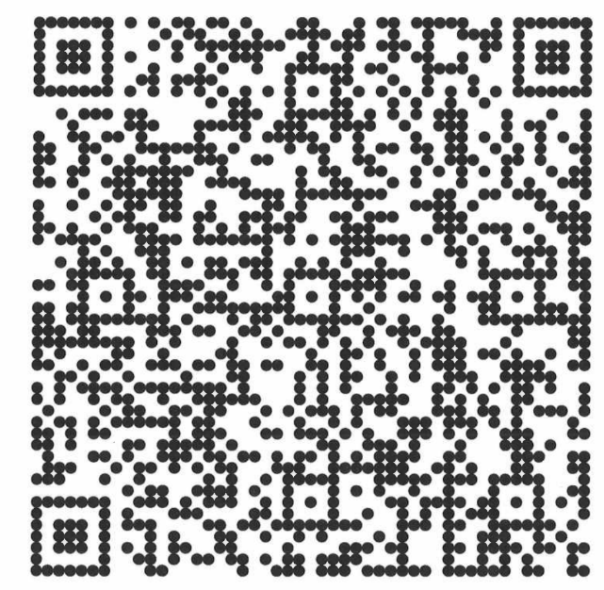
Please make all checks payable to the HHS Raiders Cheer Booster Club, LLC. All checks and this form are due by 9/30. You can also Venmo payment to @HHSRaidersCheerBoosterClub (last 4 digits 4916).

Mail to:

Hillsborough Raiders Cheer
601 Rt. 206
Suite 26-232
Hillsborough, NJ 08844

The HHS Raiders Cheer Booster Club, the HHS Cheerleading Staff,
and the HHS Cheerleaders thank you for your support!

